**PRAKTIKUM 2**

Nama : Ananta Satya Dhamma

NIM : 18090003

Kelas : 5C

1. Source Code

Latihan1.php => controller

Latihan2.php => controller

Model1.php => model

view-latihan1.php => View

1. Url

<http://localhost/Pustaka_booking_anan/index.php/Latihan1/penjumlahan/5/3>

<http://localhost/Pustaka_booking_anan/index.php/Latihan2/penjumlahan/5/3>

1. Capture Output Program

**Latihan1**

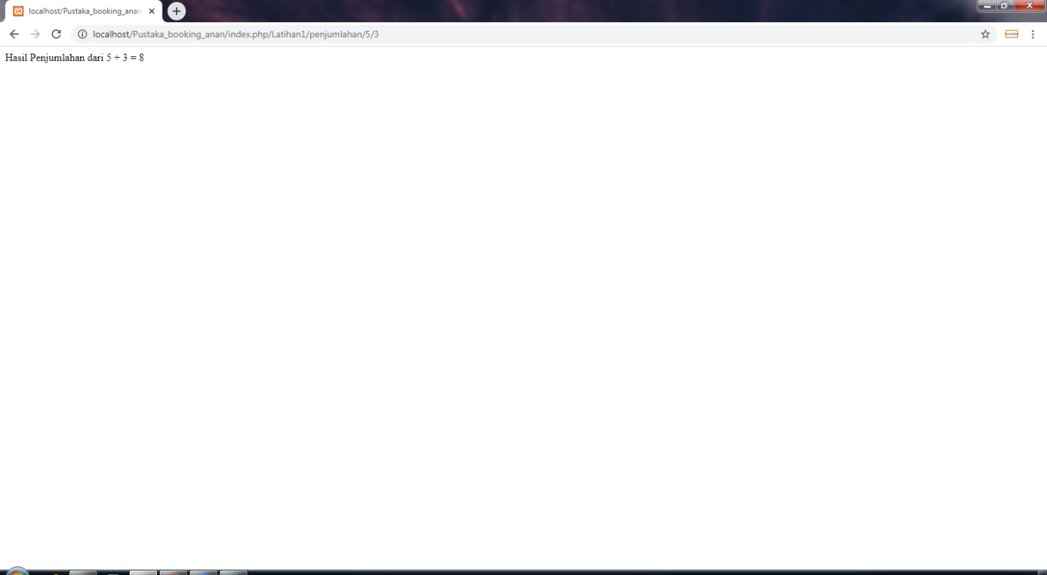

**Latihan2**

